|  |  |  |
| --- | --- | --- |
| **Philadelphia Federation of Teachers Health & Welfare Fund & Union** | **Evaluation Requested By**: PFT H&W Fund & Union **Page 1 of** | |
| **Date Inspected**: 12/2/2013  **Initial Inspection?** **☐**  **Follow-Up Inspection?** ☑ | **Inspected by:** Jerry Roseman M.Sc. I.H.  **Others Present? N**  **Name[s]:** |
| **IEQ Evaluation & Inspection Summary Report – OEC E.S. & Annex** | **Date Report Issued**: 12-2-13  **Report Provided To:** Arthur Steinberg, PFTH&W Fund | Photos Attached**: ☑**  Sketches Attached: **☐** |
| **Building Name:** Overbrook Education Center [OEC] & Annex **Building Address:** 6722 Lansdowne Ave. **Phone #:** 215-581-5890  **Main Contact[s]:** S. Pritchard [PFT Rep]; Angela Thompson [Principal]; Mr. Hester [B.E.] | | |
| **Inspection Overview:** This evaluation was requested by the PFT & conducted in response to building occupant concerns about water/moisture intrusion, mold and related health impacts. Information was provided [and observations/measurements made] about:    [1] Water stained, damaged and moldy [in a few cases] ceiling tiles were observed in several 3rd floor areas of the Main Building;  [2] Occupants reported frequent leaks from HVAC components [above drop ceilings] in 3rd floor areas – occurs during AC season [confirmed by B.E.];  [3] The 3rd floor Library [Main Building] was the area most severely impacted by water/moisture intrusion as documented by stained ceiling tiles and occupant reports;  [4] In room 301 a moldy section of drywall had been removed [approximately 2 months ago] leaving a large opening in the classroom wall and without information about the “root cause” being addressed;  [5] Mold remediation work began in the Annex [Basement Music Rooms] on or about 11/25 and is ongoing – completion is reportedly by 12/3-12/4 – **no information had been provided to us about this work or follow-up [Brian J has been at the site over the past week or so]**;  [6] Suspect mold growth was observed at the bottom of painted metal door frames in several areas in the OEC Annex [photo documentation is provided];  [7] Thermal control and general indoor air quality deficiencies were reported by OEC Annex occupants [confirmed by observation and measurement]    **It should be noted that despite repeated requests to OEMS-PSD about obtaining information, status and updates, and to coordinate inspection activities, no response was ever received from Francine Locke or Jerry Junod, nor did anyone from the PSD participate in the inspection.** | | |
| |  |  |  | | --- | --- | --- | | **Room – Area Inspected** | **Relevant Observations, Findings & Measurements** | **Comments-Recommendations-Informational Request** | | Main Building-  Building Wide Issue | * Water stained and damaged ceiling tiles were observed in many areas, primarily on the 3rd floor but also in other areas of the Main Building  * As reported, and based on evaluation, it appears as if the primary source of the problem is condensation-related [HVAC] | 1. Identify and replace all water stained and damaged ceiling tiles throughout the Main Building;  2. Perform an evaluation of HVAC system operation [AC particularly] to identify problems/issues with condensation, insulation, etc. & effect repairs as necessry | | Main Building 3rd Floor Computer Room | * Two [2] stained ceiling tiles – mold growth observed on 1  * Active “leaking” from HVAC/condensate during AC season was reported by occupants | 1. Replace damaged tiles and conduct a root cause evaluation to determine the source of the water intrusion/moisture;  2. Effect repairs of the root cause[s] as necessary | | Main Building  Library | * Approximately 20-24 stained ceiling tiles observed – 1 with visible mold.  * Active “leaking” from HVAC/Condensate during cooling season was reported by occupants | 1. Replace damaged tiles and conduct a root cause evaluation to determine the source of the water intrusion/moisture;  2. Effect repairs of the root cause[s] as necessary | | Main Building  3rd floor – Girls & Boys bathrooms | Stained ceiling tiles observed – B.E. was unsure if damage was recent or long term | 1. Replace damaged tiles and conduct a root cause evaluation to determine the source of the water intrusion/moisture;  2. Effect repairs of the root cause[s] as necessary | | Main Building  3rd floor – Hallway areas | Stained ceiling tiles observed – B.E. was unsure if damage was recent or long term | 1. Replace damaged tiles and conduct a root cause evaluation to determine the source of the water intrusion/moisture;  2. Effect repairs of the root cause[s] as necessary | | Annex  Basement Music Rooms | * PSD remediation workers started mold remediation on, or about 11/25 – work reportedly to be completed sometime in the next few days  * Some repair/adjustment reportedly made to the heating/HVAC system to address excessively cold temperatures previously documented | 1. Provide information, status and scheduling for this work – copies and summary information should also be presented to building staff/occupants | | Annex – 1st & 2nd floor classrooms | * Suspect mold growth observed on several painted metal door frames of classrooms including on 1st and 2nd floor classrooms  * Suspect mold growth observed on bottom, inside of metal storage cabinet in classroom #1 | 1. Evaluate all door frames, and storage cabinets for the presence of suspect mold growth and remediate as necessary; | | Annex – 1st & 2nd floor classrooms | *Many classrooms were overheated and there was inadequate/no air circulation detected  *Rm 1 – unable to open windows because of pest intrusion concerns – no air movement/circulation detected;  *Rm 23 – also lack of air circulation – CO2 levels of 1400 ppm measured [16 students and 2 staff] | 1. Evaluate HVAC operation & function to determine problems with circulation, air movement and overheating – effect repairs as necessary;  2. Address the pest/rodent issues re: room #1 [and perhaps impacting other areas as well] and implement a response to allow windows to be safely opened;  3. Assess general IAQ, and OA volume to ensure CO2 levels are maintained below 1000 ppm | | Annex Building Wide | Staff/occupants expressed concerns about respiratory illness and symptoms being experienced and the relationship to the mold growth found at the site | 1. Provide a detailed summary and status about building conditions and remediation work conducted to date and addressing the issues raised in this report | | | |

**Inspection Summary**

**[1] Evaluation Overview -** The 12/2/13 inspection was a follow up and should **not** be considered as a comprehensive summary of all impacted areas and issues – however, given the findings reported here, additional inspection and assessment by OEMS-PSD is required. It would be advisable to conduct additional evaluation in a joint manner;

**[2] Water** **– Moisture –Dampness – Mold - Main Building** – Water damaged, stained and moldy ceiling tiles were observed in the main building, primarily on the 3rd floor but also in other areas of the building. As per the 12/2 evaluation, and building occupant reports, these conditions appear most likely related to condensation and dampness/moisture associated with the newly installed HVAC system. **Although mold was observed in only a few areas, these conditions are a major concern given the recent history and extensive work conducted at OEC**

**[3] Replacement of Water Stained, Damaged & Moldy Ceiling Tiles & Cleaning of Door Frames and Other Surfaces with Suspect Mold Growth–** Especially given the school population at OEC [and it’s Annex], including very young children and those with visual impairments and other disabilities, remediation work related to water damaged and moldy materials should be promptly conducted

**[4] OEC Annex IAQ General –** The 1st and 2nd  floors of the OEC Annex appeared to have very limited/no air circulation and/or movement and, in room 23 measured CO2 levels exceeded 1420 ppm – an evaluation of the HVAC system operation is therefore recommended in order to effect necessary repairs and improvement

**[5] OEC – Annex Room 1–** As described above [and pictured] classroom windows are unable to be safely opened because of the risk of animal intrusion [the photo below shows what was reported to be an opossum nest built outside of the classroom window]. This situation should be addressed to facilitate the introduction of fresh air into the classroom;

**[5] Mold Remediation – Annex Music Rooms -**  Mold remediation and cleaning of musical instruments reportedly began on, or about 11/25 – no notification, information or status was reported to us, nor was there a formal notification reportedly provided to building occupants or others [including parents]. Concern was expressed by several staff about the potential impacts on young children, several of whom reportedly have severe asthma, and also about the health impacts on staff;

**[6] Information Sharing**

* All reports, summaries and information related to remediation should be provided to PFT H&W Fund/Union representatives & building occupants in a timely and ongoing manner;
* An E.A.T. should be restarted at Lowell to facilitate an effective joint and accountable process for working in a collaborative way to solve ongoing IEQ-related problems and issues;
* Critical review and follow-up related to root causes and previous evaluations and a lessons-learned approach should be implemented;
* A transparent, and collaborative process should be implemented, involving all stakeholders, customers and participants to facilitate an effective response to addressing health and safety concerns at Lowell

**\*\* *The situation re: moisture, dampness and water leakage, in the main building of OEC, especially associated with HVAC operation is of special concern and demands critical, immediate and robust response. This school had major renovation conducted, and new systems – including HVAC – installed, approximately 8-9 years ago at significant cost. Through a combination of design, installation and, maintenance deficiencies and neglect, the “newly” installed systems failed catastrophically resulted in the closure of OEC for the 2011-2012 school year. Students and staff had to be relocated – for the 2nd time in 7-8 years – to the Turner M.S. while a major environmental-mold remediation effort was conducted and extensive renovation of HVAC and other systems done. The total costs reportedly exceeded $2 million.***

***The conditions observed in the main building, particularly on the 3rd floor, while much less extreme than similar conditions observed in the summer of 2011, nevertheless exhibit some of the same elements with water staining and mold on ceiling tiles and reportedly associated with HVAC-condensation issues [a major source of the prior damage].***

***Accordingly, a comprehensive, systematic and professional evaluation is called for at this location.*PHOTO LOG -** **Selected & Representative** **Photos**

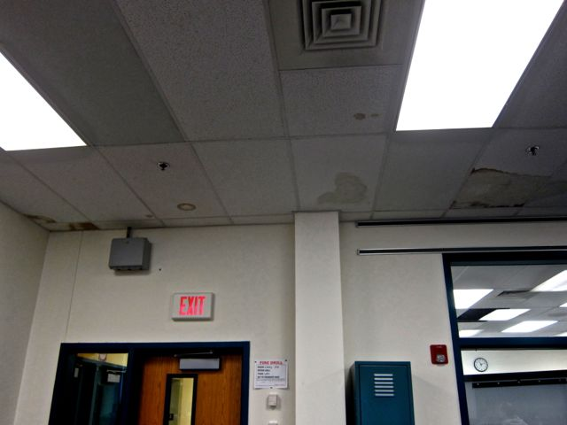

**OEC Main Building – 12/2/13 – Library – 3rd floor**

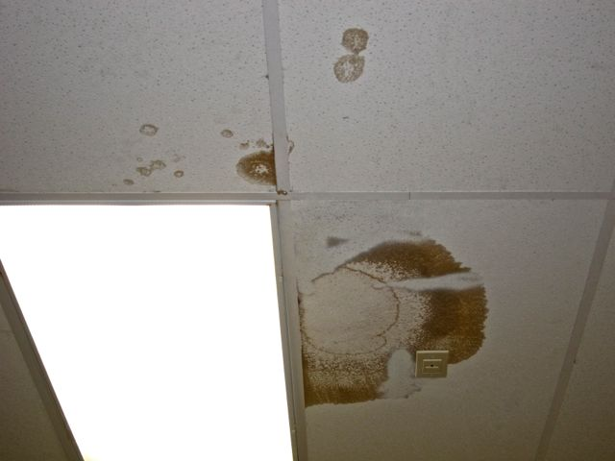

**OEC Main Building – 12/2/13 – Library – 3rd floor – Water damaged/stained ceiling tiles**

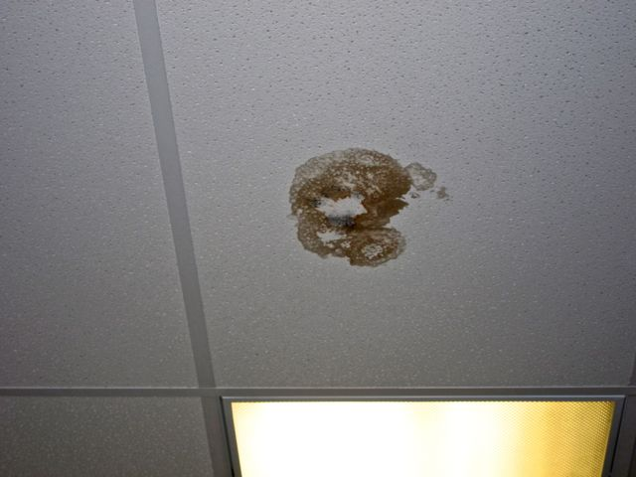

**OEC Main Building – 12/2/13 – Library – 3rd – Mold growth on ceiling tile**

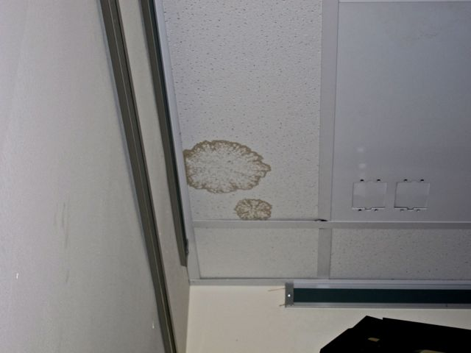

**OEC Main Building – 12/2/13 – Library – 3rd floor – water damaged ceiling tiles**

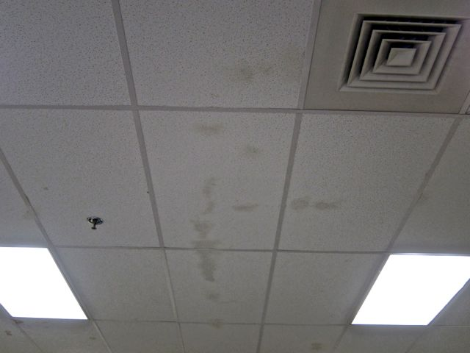

**OEC Main Building – 12/2/13 – Library – 3rd floor**

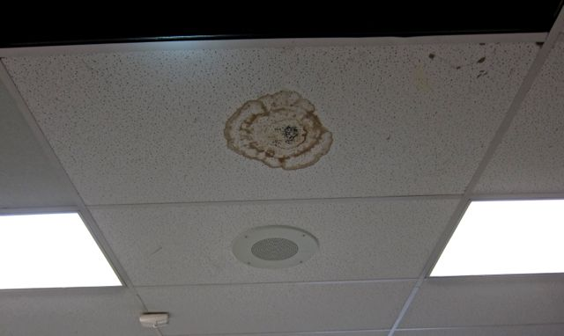

**OEC Main Building – 12/2/13 – Computer Lab – 3rd floor**

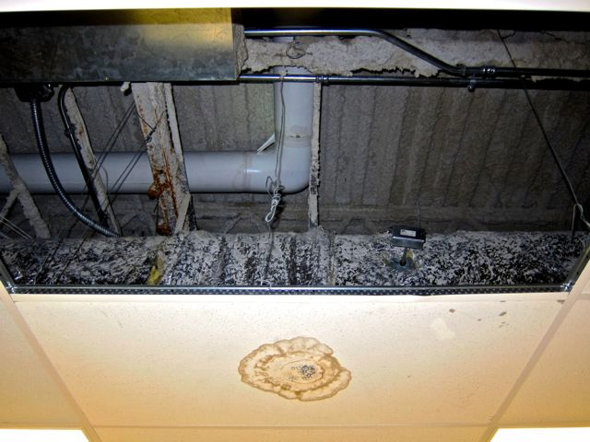

**OEC Main Building – 12/2/13 – Computer Lab – 3rd floor – Close Up – Showing chilled water line and HVAC components**

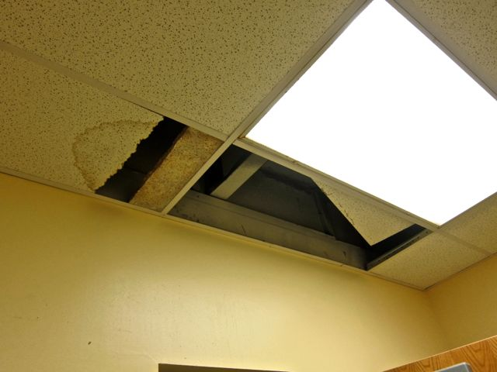

**OEC Main Building – 12/2/13 – 3rd floor – Girl’s Bathroom Ceiling**

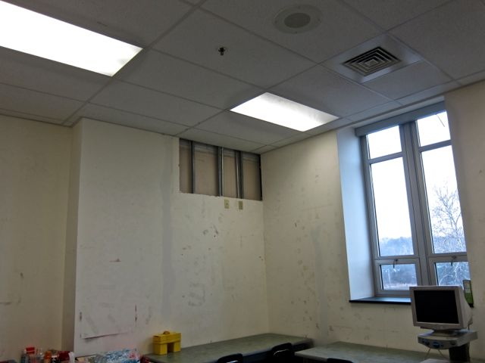

**OEC Main Building – 12/2/13 – Room 301**

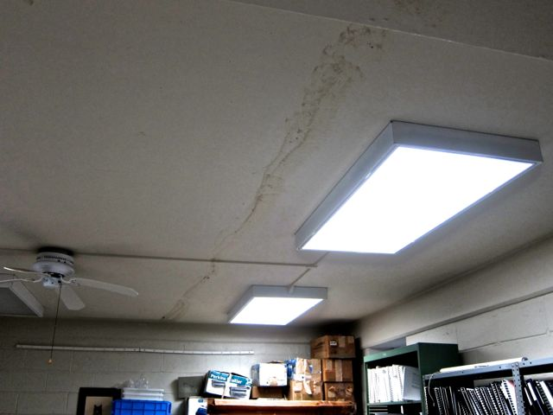

**OEC Annex – 12/2/13 – Music Suite Ceiling – Water Damage**

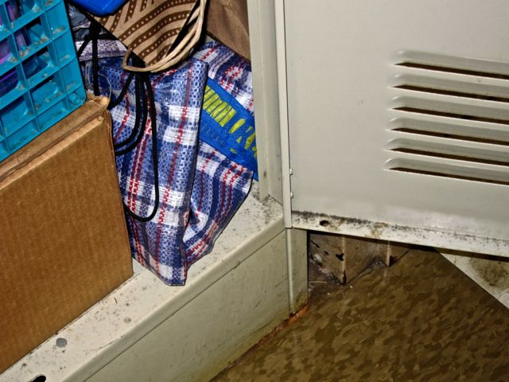

**OEC Annex –12/2/13 – Classroom 1 – suspect mold growth in storage cabinet**

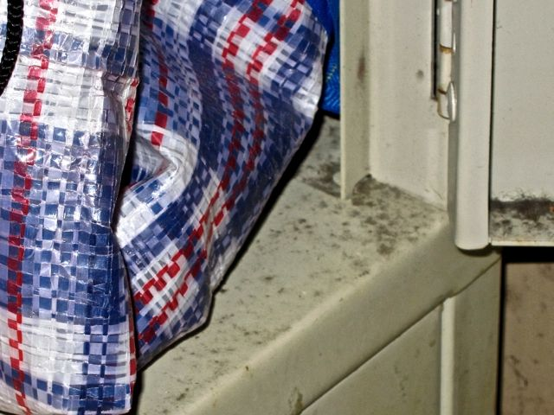

**OEC Annex –12/2/13 – Classroom 1 – suspect mold growth in storage cabinet – close up**

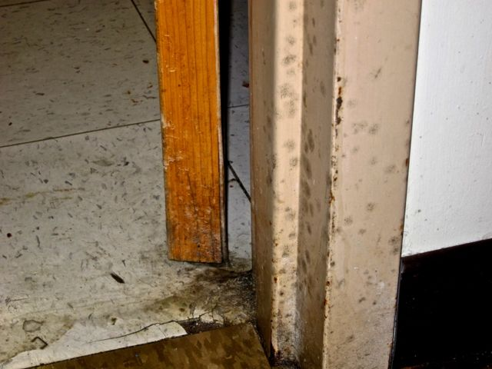

**OEC Annex –12/2/13 – Classroom 1 – suspect mold growth on door frame**

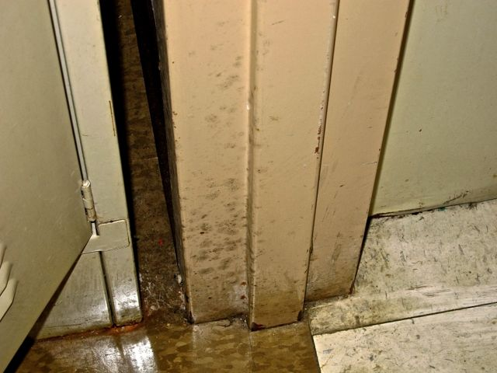

**OEC Annex –12/2/13 – Classroom 23 – suspect mold growth on door frame**

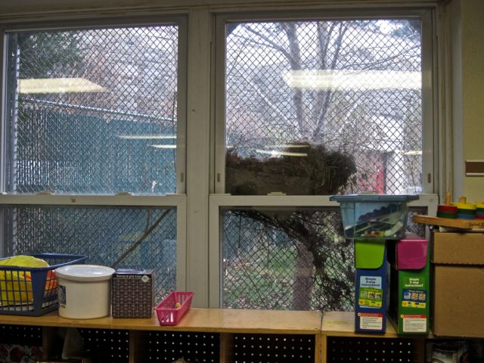

**OEC Annex –12/2/13 – Classroom 1 – rodent nest outside window**

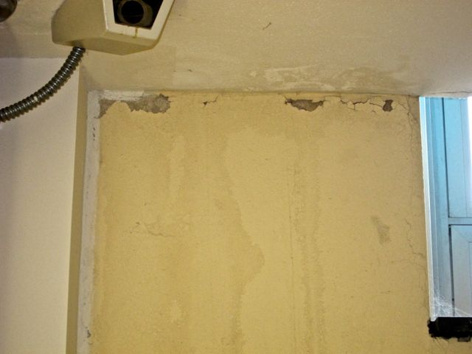

**OEC –12/2/13 – Stairwell G – Top Floor Landing – Chipping Paint and plaster from water damage**